GMA OTS solution

Problem Definition:

Current business process:
- A product is developed and sold to different customers.
- Most customers have very specific packaging and ticketing requirements.
- Packaging and ticketing are done on this product at the factory before they are shipped.
- Upon receipt of goods in warehouse, correct qty of this product manufactured for a specific customer order must be shipped on time.

Current system setup & Usage:
- Each unique product is setup as one style/color regardless of any customer configuration on this product.
- One pool of inventory holding all variations of this style/color.
- Different Sales orders are allocated to the production Order for this style/color to know whom to ship when the production order is received.

Current Problems faced:
- Upon receipt of PO into inventory, the PO/SO allocation is no longer valid.
- EXCELL spreadsheets have to be maintained to track this allocation and OTS.

PRODUCT: NMS-480 – LTBLU
Supply Demand

PO

SO
ALLOCATION

PO

SO

PO

SO

Receiving

Inventory pool

Manual process to know who to ship what
Manual process to know who to ship what

Customer

Customer

Customer

Solution details:
- Use a product centric approach
- Setup each configuration of the product as a separate product ID but under the same style color.
- A default configuration has to be created for every style/color.
- Inventory will be kept at style/color/configuration/warehouse level.
- All transactions will hold style/color/configuration.
- PO/SO allocation will not be required. Instead finished goods allocation will be done prior to receiving but including shipments in transit in the process.
- Sales will be matched with purchases based on dates and configuration.

Inventory Structure:
The new inventory structure will be as follows:

Style

Color

Configuration

Warehouse

NMS-480 | LTBLU | APWLM10000 | NJ
NMS-480 | LTBLU | APWLM10000 | LA
NMS-480 | LTBLU | APKOH10000 | NJ
NMS-480 | LTBLU | APKOH10000 | LA
NMS-480 | WTCMB | ASGMA10000 | NJ
NMS-480 | WTCMB | BSGMA10000 | NJ
NMS-480 | WTCMB | APWLM10000 | LA
NMS-480 | WTCMB | APWLM10001 | LA
Configuration field:

- Free format alphanumeric field
- 10 character max length
- Free format notepad available to describe the configuration details.

Suggested Coding structure
1
1
5
3
A – Group “A”

B – Group “B”
P – Private label

S – GMA Stock
Valid customer code:
- WAL10
- KOH10
- GMA10 for stock
Sequential # to uniquely identify multiple configurations for the same customer
GROUP
TYPE
OWNER
SEQUENCE#

As shown above, this configuration field is part of the key to identify a unique inventory item and it is tracked on all the transactions from the supply and demand side all the way through the distribution process.

The concept is described in the figure below:

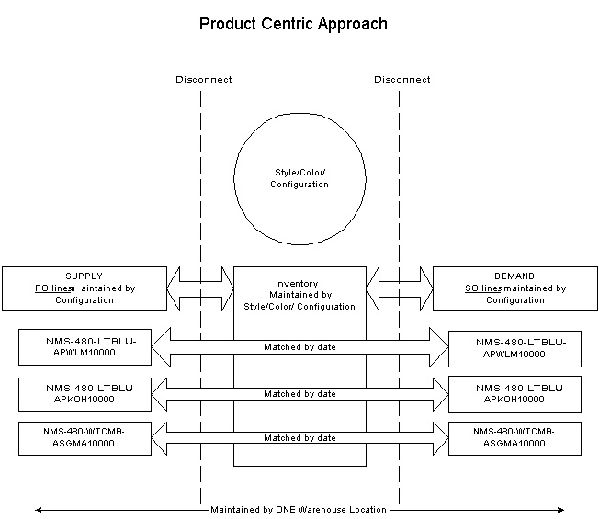

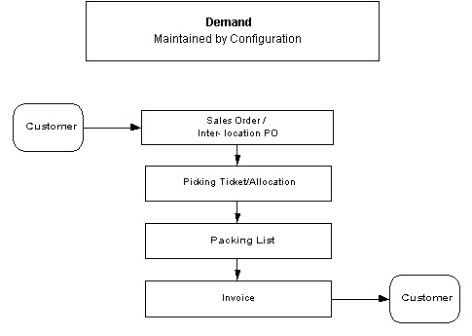

Sales Orders:

- New configuration can be created for any style/color being ordered.
- Existing configuration can be selected from a list for any style/color being ordered.
- Upon creating a new configuration, user will be able to enter unlimited notepad to describe the configuration details.
- List showing existing configurations will have the notepad displayed in the list.
- A style/color marked as coming in configurations cannot be entered on a sales order without specifying a configuration.

Allocation:

Allocation by Order and by Style:

- Allocation will be done against stock at the style/color/configuration level.

Automatic Allocation:

- Allocation can be done against stock or shipments in transit at the style/color/configuration level.
- User can choose to include Shipments in transit or not.
- Upon choosing to include shipments in transit qty, user can select open shipments based on the following:
  - Shipments ETA date range
  - Shipments in list where user can select one or multiple shipments

Picking tickets:

- Pick tickets will be printed with style/color/configuration.
- Warehouse employees will pick goods based on Style/color/Configuration. An assumption is made that factories will include Configuration on the carton markings.

Packing List:

- Style/color/configuration from the picking ticket will be carried over to the packing list lines.

Shipping:

Invoice from sales orders:

- Style/color/configuration from the picking ticket will be carried over to the Invoice lines.
- Inventory will be decreased at the style/color/configuration level.

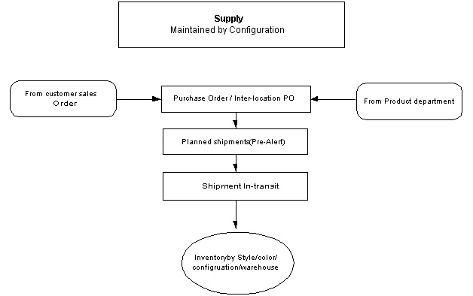

Purchasing:

Style PO & Inter-location PO:

- New configuration can be created for any style/color being ordered.
- Existing configuration can be selected from a list for any style/color being ordered.
- Upon creating a new configuration, user will be able to enter unlimited notepad to describe the configuration details.
- Ability to specify the COMPLETE date, SHIP VIA and packing fields at the PO line level.
- Ability to see planned shipments (Pre-Alerts) for any PO line.
- Ability to see summary transactions on one screen for any specific PO line.
- For Inter-location POs, ability to create cost sheet where user can add any additional cost that may be incurred on a specific Inter-location PO.
- A style/color marked as coming in configurations cannot be entered on a Purchase order without specifying a configuration.

Following is the new screen design for the P/O detail folder:

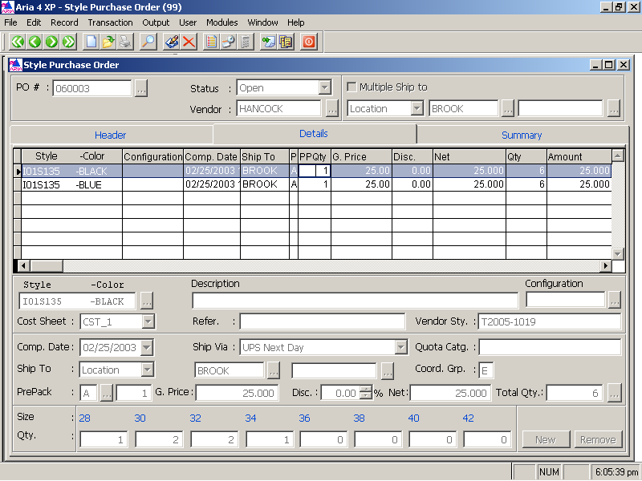

Following is the new screen design for the P/O Summary folder:

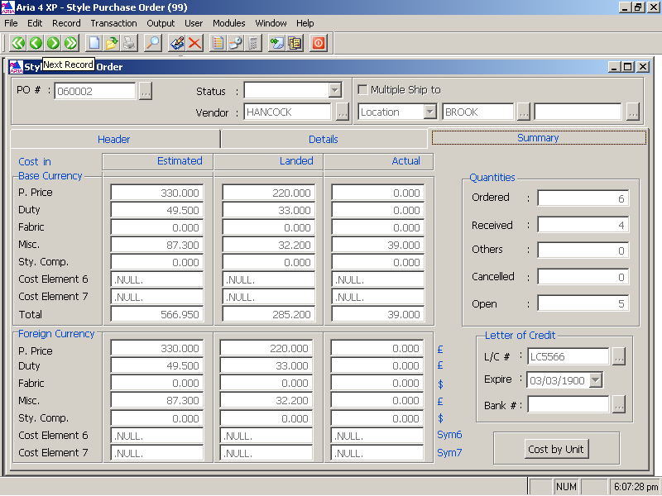

Planned shipments (Pre-Alert):

- Pre-Alerts are referred to as Planned shipments in the system.
- Web based supply chain module is being developed with the following key features:
    - Login and security by:
      - Vendor
      - Buying Agent (handling multiple vendors)
      - Buyer (GMA internal user)
    - Vendor or the buying agent can acknowledge one or all new PO lines. Upon acknowledging, planned shipment lines are created for each of the acknowledged PO lines.
    - Vendor or buying agent can either modify or split one planned shipment line into multiple lines. These changes will be marked as unapproved.
    - Buyer (GMA user) can view all unapproved planned shipments lines and approve one or all.
    - Ability to filter and view selected PO lines, planned shipment lines or unapproved planned shipment lines.
    - Ability to create and check messages easily with visual notifications.

Following is the screen design for the PO filter screen on the supply chain module:

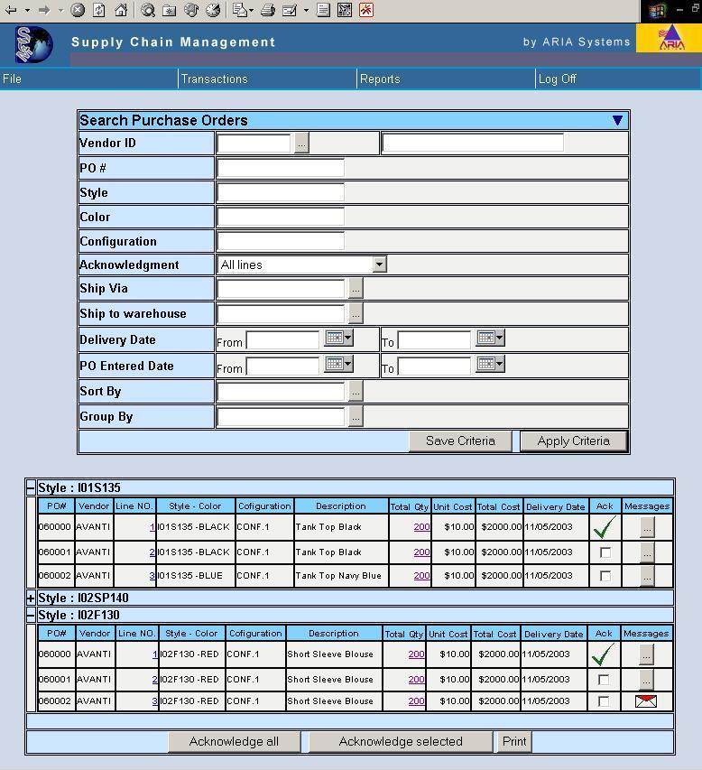

Following is the screen design for the PO line detail screen on the supply chain module:

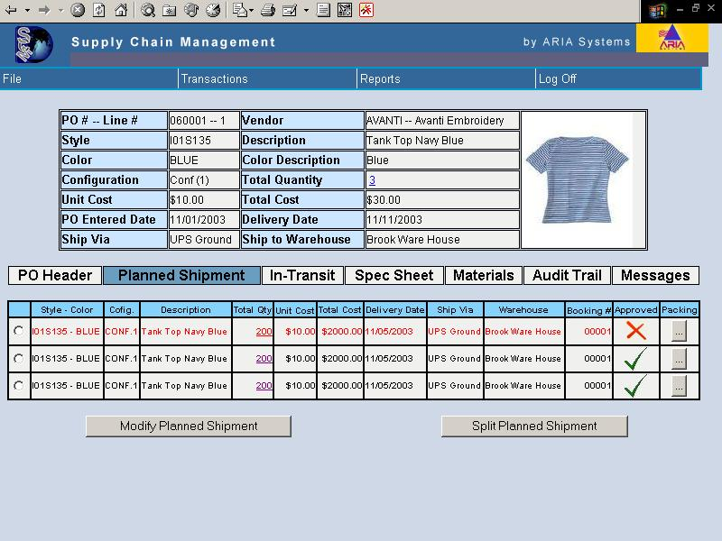

Following is the screen design for the Planned shipment filter screen on the supply chain module:

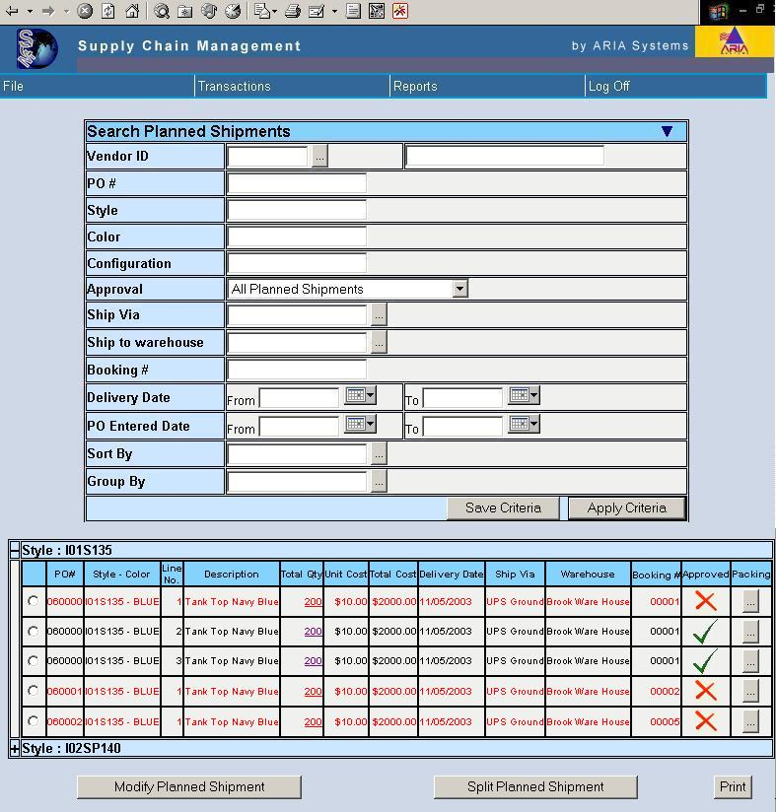

Shipments:

- Shipment lines will hold PO/style/color/configuration

Master Production scheduling Tool:

A new tool being developed as part of the Supply Chain module with the following key features:

- Instantly see stock availability by week for any style/color/configuration within one warehouse.

- Point at any one-week for any one style/color/configuration/size and see all the detail transactions that make up the total number being displayed for the week.

- Any week for any one style/color/configuration/size with a stock level below a threshold number will be highlighted with different colors based on severity of the problem.

- Action messages generated automatically for all weeks that have any sort of a problem with meeting deliveries on time.

- This tool depending on the nature of the problem can perform pre-defined set of actions. For example, it can send auto email notifications to vendor or sales people with detail information and suggested action.

- A batch process will run nightly to aggregate all transactional data by warehouse/style/color/configurations/size so that data can be available instantly on this tool.

Following is the suggested screen layout for the MPS screen:

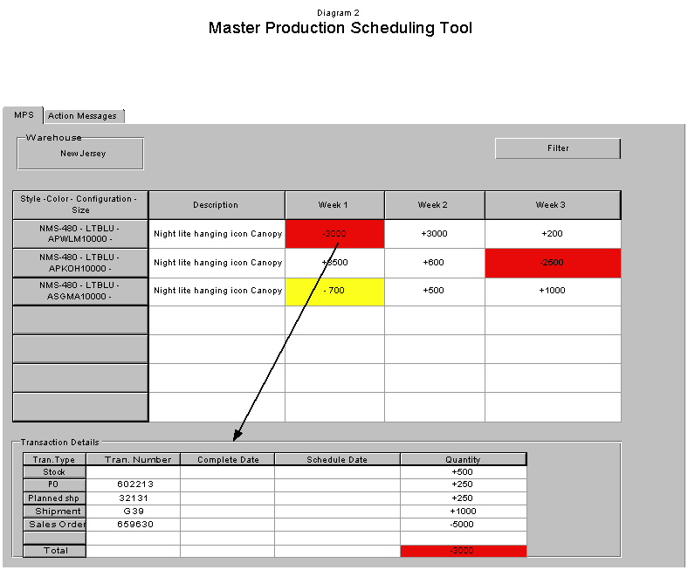

Following is the suggested layout of the Action messages screen:

